
QUALITY ALERT

Customer: Golden Date: February 19, 2022
DIE: 15602 Colour: WH -141
Type of Complaint: Golden REJECTS

Q.A # Q.I.R # CUSTOMER NCR #

Description: Customer REJECTS due to flex is distorted (FOLDING/WAVING).
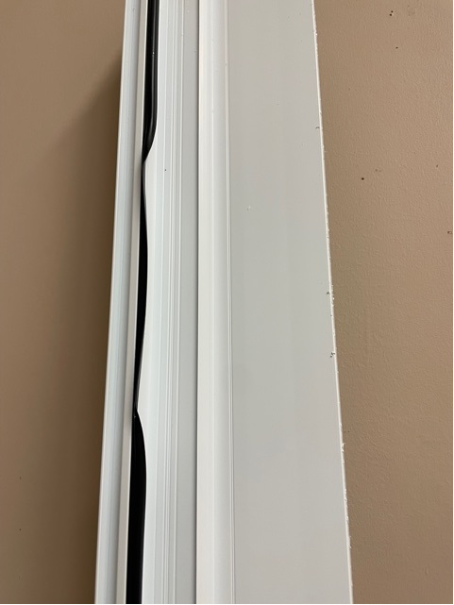
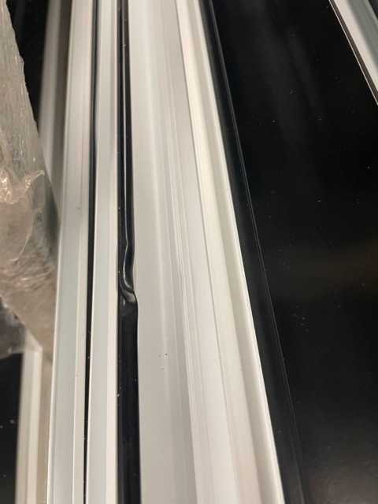

PLEASE MAKE SURE THE FLEX IS NOT FOLD DURING THE PACKAGING

BY SIGNING BELOW, YOU ACKNOWLEDGE THE PROBLEM ABOVE AND AGREE TO MONITOR THIS ISSUE IN FUTURE PRODUCTION RUNS.
DAY SHIFT |  | AFTERNOON SHIFT |  | NIGHT SHIFT
NAME | SIGNATURE | NAME | SIGNATURE | NAME | SIGNATURE

